PHOENIX ART SPACE: STUDIO APPLICATIONS PACK

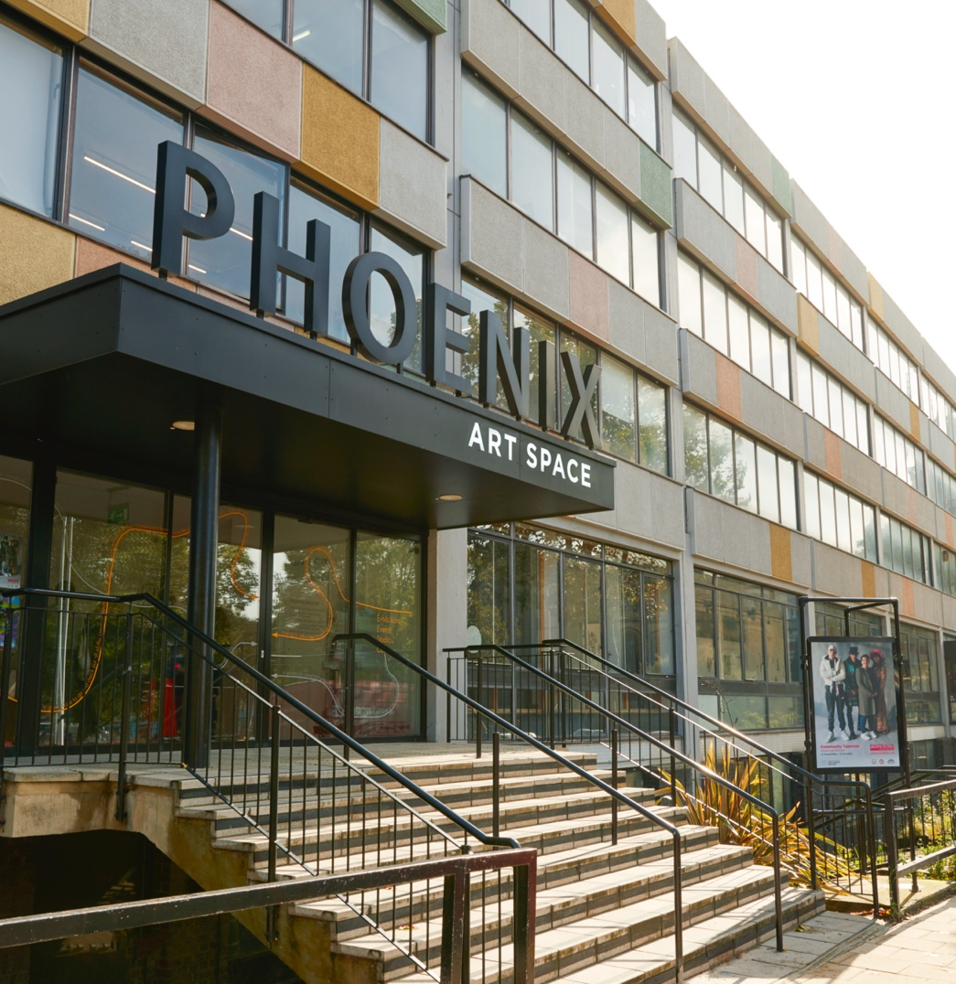

Contents

BACKGROUND INFORMATION 3-4

Our Vision, Mission and Values

Studio Use: Space, Fees and Membership

ELIGIBILITY FOR STUDIOS AT PHOENIX 5-6

SELECTION PROCEDURE 7

HOW TO APPLY FOR A STUDIO 8

SECTION 1 9-15
Privacy Notice, Consent and Eligibility Questions

SECTION 2 16-19
Visual Practice Information

CHECKLIST 20

BACKGROUND INFORMATION
We are a membership organisation and charity, housing over 120 artists working in a range of disciplines in affordable studio spaces over 6 floors in the centre of Brighton. We also present year-round gallery, events, education and community engagement programmes and have an onsite café.

OUR Vision
We bring people together through contemporary art to imagine and shape a more inclusive, sustainable and inspiring world. Looking ahead, we will build on this strong foundation to:
- Set a national standard for how creative spaces nurture artistic talent, activate communities, and catalyse civic change.
- Transform our building into an exemplar of accessible, environmentally responsible design.
- Expand our role as a centre for experimentation, critical dialogue, and international artistic exchange.
- Ensure that diverse voices shape the future of contemporary art, here and globally.
We believe that art should be a part of everyone’s life — a way to see the world differently, and a means to rethink and rebuild more equitable, connected futures.

OUR MISSION
We believe that creativity should be a right, not a privilege — and that culture, when equitably supported, can be a powerful force for positive change. Our mission is to:
- Champion diverse artistic talent by providing affordable, high-quality studio and exhibition spaces.
- Deliver an ambitious programme of exhibitions and public engagement that opens up contemporary art to new audiences.
- Build inclusive communities through creative learning, conversation, and participation.
- Create sustainable pathways for artists at every career stage — from early development to international collaboration.
- Lead Brighton & Hove’s creative future by advocating for the arts and forging partnerships that strengthen cultural, environmental and economic wellbeing.
And we do this by living and holding ourselves accountable to the following set of values.

Our Values
- Creative Innovation: We value curiosity, experimentation and the freedom to try new things. Innovation in creative practice is vital to the health of individuals, communities and culture and we embrace risk as a route to discovery.
- Radical Respect: We treat all people with fairness, empathy and dignity. We hold space for difference, and support people to thrive on their own terms, in their own voice.
- Responsible Futures: We are committed to environmental and social responsibility within our spaces and the systems we shape. We embed sustainable thinking across our operations and aim to reduce our impact wherever possible. We recognise our role as a civic organisation, one that supports climate-conscious, socially just futures through inclusive programming, ethical governance, and by sharing what we learn.
- Equity in Action: We believe in the power of diversity and inclusion to drive excellence. We challenge structural inequalities, strive to be anti-racist, and work to centre underrepresented voices across all that we do.
STUDIO USE: SPACE, FEES AND MEMBERSHIP COMMITMENTS
Studios range in size from 10 to 36 sq. metres, with the majority being between 15 and 20 sq. metres. Some studios are shared by two or more artists. Each studio differs, and if you have very specific requirements e.g. needing a sink or lower floor, this limits the number of studios that will be suitable for you. Studios cannot be used only for storage or exhibitions.
Studio License Fees are costed at a per square metre rate. The 2026 rate is £11.26 per sqm (e.g. a 20 sqm studio is £ 225.20/month plus electricity). Electricity is currently charged at £0.81 per sqm. License Fee and electricity are invoiced monthly in advance. A deposit of 1 months’ fees must be paid in advance. Licence fees are subject to an increase each year. We ask for you to give one month’s notice if you need to vacate or sublet. Subletting is arranged by Phoenix and offered to artists on our waiting list. If for any reason we require to ask for your studio to be vacated, we will give you two months’ notice.
By holding a License at Phoenix Art Space you become an Associate Member and beneficiary of the charity. Phoenix currently offers its Membership exhibition opportunities and discounted rates for courses and space hire. There are opportunities through the year to volunteer with Phoenix Art Space such as with planning Open Studios.
As part of being a member of Phoenix Art Space you are expected to commit to a minimum of 18 hours studio time per week. You are also expected to be part of the annual Open Studios event, held in May, across a Friday evening and weekend, and you may be asked from time to time to contribute to planned studio tours.

ELIGIBILITY FOR STUDIOS AT PHOENIX
Our studios are in high demand and are currently full. Any artists selected through this process will at this time ONLY join our Pool List of selected artists waiting to take up sublets and studio spaces as and when they become available.
Our studio eligibility criteria are grounded in our Charitable Objects, which are informed by the Equalities Act 2010. Phoenix Art Space exists: For the public benefit to promote the arts; to promote equality and diversity in the arts; and to educate the public in the production and the appreciation of the arts; in particular but not exclusively by providing exhibition and studio spaces for emerging artists and those in necessitous circumstances due to their age, race, gender, disability, sexual orientation or financial hardship particularly in the towns of Brighton and Hove, and in other areas of the South East of England.
To be eligible for a studio space at Phoenix Art Space, studio artists should fulfil one or more of our eligibility criteria:
- An emerging or re-emerging artist; and/or
- Part of an under-represented group due to your age, race, gender, disability, or sexual orientation; and/or
- In necessitous circumstances due to financial hardship.
We believe that we will have a greater impact when our charity reflects the city in which we work, and we particularly welcome applications from those who will bring a different voice to our community. We aim to achieve a balance of gender, ethnicity, age, and practice diversity within the studios and this will be considered when allocating space.
A note on why we are asking these questions and how your answers will be used
As you will see from our Charitable Objects above, one of our core aims is to promote equality and diversity in the arts. We work towards this by providing studio space to those who meet our eligibility criteria - whether as emerging or re-emerging artists, or due to factors such as age, race, gender, disability, sexual orientation, or financial hardship.
We define an emerging or re-emerging artist as someone who has been actively practising for up to 10 years, not including significant breaks (e.g. childcare, illness, caring responsibilities). This includes artists who began their practice later in life. We use this definition to reflect the real and uneven paths of artistic development.
We ask applicants to self-identify across categories such as age, ethnicity, gender identity, sexual orientation, and disability or neurodivergence. To assess financial hardship, we ask applicants to reflect on their ability to meet essential living costs, access resources for their practice, and sustain income from artistic work. We also invite applicants to self-identify their class background, acknowledging that socioeconomic status, while not a protected characteristic, continues to influence access to the arts.
In this form, to assess eligibility, we ask for some personal information, including sensitive data. This helps us ensure our resources are reaching those who would benefit most and supports our ability to deliver on our charitable objectives.
We rely on applicants to answer these questions honestly and all information you share will be treated as confidential and used only for studio allocation decisions. The security of your personal information is of high importance to us. Please see our Privacy Notice on page 9 for more information on how your data will be securely held. If you would like to see our full data protection policy, please request this from Kate Neave, Studios Manager, kateneave@phoenixartspace.com.
Please answer the questionnaire as openly as possible. If any question doesn’t fit your situation, you’re welcome to explain your circumstances in the spaces provided.
Please ensure that you have carefully read all sections of this form, and our eligibility criteria, before applying. It is essential that you evidence the fulfilment of our criteria through your application.

SELECTION PROCEDURE
We generally select 8 - 12 artists at each selection to join our Pool List in each round. On average, only 4 – 5 studios become available each year, so please be aware that artists can wait for some time for a studio. Your application will first be reviewed by the Phoenix Art Space team, who will create a shortlist of 30 applications for consideration by the full selection panel.
The panel is comprised of:
- Executive & Artistic Director, Phoenix Art Space
- Studios Manager, Phoenix Art Space
- One Phoenix Art Space studio artist
- One artist, curator or critic external to Phoenix Art Space
Applications can only be made during our annual Open Call dates. Successful applicants will be notified by email. Due to the high number of applications we receive, we are not able to provide individual feedback to artists.
Applications can only be accepted from individual artists and collaborative artist collectives at this time. We are not accepting applications from artists working individually that wish to share a studio space. If you are part of a collaborative practice then evidence of collaborative working should be demonstrated clearly through this application form.
Once eligibility is confirmed, applications are assessed on the strength of artistic practice. All applicants will be notified of the outcome within 4 weeks of the date of the meeting. Successful applicants may be invited for a brief interview and will join the Pool List until a suitable space becomes available.

Interview
Artists may be asked to attend a short interview with the Studios Manager, Executive & Artistic Director and a Phoenix Art Space studio artist.

References
If your application is successful, we will require a reference from someone you have worked for or with professionally and within context of your current practice. You will be asked to provide contact details for a referee in your application.

HOW TO APPLY FOR A STUDIO
To apply for a studio, artists must send the following to the email address: studioapplications@phoenixartspace.org:
SECTION 1 – COMPLETED ELIGIBILITY INFO AND CONSENT

SECTION 2 – COMPLETED VISUAL PRACTICE INFORMATION WITH IMAGES AND C.V.
PLUS COMPLETE OUR ONLINE EQUAL OPPORTUNITES MONITORING FORM
We are committed to making our opportunities accessible to all. Applications can be submitted in different formats to this form, such as but not limited to, audio files, video, and video with BSL files. If you need any support to complete your application, including talking through the questions in person as your application, please get in touch. We're here to help.

SECTION 1 – ELIGIBILITY FOR STUDIOS AND CONSENTS

PRIVACY NOTICE AND APPLICANT DECLARATION
Phoenix Art Space is a registered charity providing studio space and support for emerging and re-emerging artists, artists in financial hardship, and artists from under-represented groups. We are the data controller for the information you provide. Contact: kateneave@phoenixartspace.org. Address: Phoenix Art Space, 10–14 Waterloo Place, Brighton, BN2 9NB
Why we collect your data
We collect and use your personal information to assess whether you meet our eligibility criteria for a studio, allocate studios in line with our charitable purpose and monitor and report on the reach and impact of our work. We do not use your data for marketing or share it outside the organisation.
What data we collect
We collect personal and contact details, information about your artistic background, financial information to assess hardship, demographic details (such as gender, ethnicity, or disability) relevant to our charitable aims.
Our legal basis
We collect this data on the basis of Legitimate interests (Article 6(1)(f)) – to manage studio applications and ensure fair allocation and Substantial public interest (Article 9(2)(g)) – to advance our charitable objectives in supporting disadvantaged and under-represented artists.
How we protect and keep your data
Your data is stored securely and only accessible to authorised staff members. Any applications which fall within a grey area will be assessed anonymously by a panel. Eligibility is assessed separately before applications go to the panel to be assessed on the basis of practice information. We keep personal data for artists for the period they hold a studio at Phoenix. We also keep personal data for artists on the Pool List as long as they remain on it. We delete data from unsuccessful applicants. We keep anonymised data for up to 5 years for equality monitoring.
Your rights
You can ask to see or correct your data, request that we delete it and/or complain to the Information Commissioner’s Office (ICO) if you’re unhappy with how we handle it (see www.ico.org.uk). Contact kateneave@phoenixartspace.org to exercise your rights.

APPLICANT DECLARATION OF CONSENT
I confirm that the information I have provided is true and complete. I understand that Phoenix Art Space will use my data to assess my eligibility for a studio and to deliver its charitable aims. I have read and understood the Privacy Notice above.
I agree to the use of my personal and sensitive data as described.

Name: _________________________
Signature: _____________________
Date: _________________________

ELIGIBILITY FOR STUDIOS
You only need to meet one of the following three eligibility routes, but we ask you to complete all sections. The additional information helps us to demonstrate the true diversity of our studio membership and ensure we reach and support all under-represented groups. The data is reported anonymously to demonstrate the value of the work we do.

ROUTe 1: EMERGING/REMERGING ARTISTS
→Are you an emerging/re-emerging artist?
We define an emerging or re-emerging artist as someone who has been actively practising for up to 10 years, not including significant breaks (e.g. childcare, illness, caring responsibilities). This includes artists who began their practice later in life.
Yes [ ] No [ ]
Please tell us any information you would like us to consider in respect to your artistic career stage.

ROUTE 2: UNDERREPRESENTED GROUPS
→What is your age group?
Please choose one option
18 – 34 [ ]
35 – 49 [ ]
50 – 64 [ ]
65 – 74 [ ]
75+ [ ]

→What is your ethnic group?
These categories are reproduced from the 2021 Census of England and Wales.

Asian or Asian British
Indian [ ]
Pakistani [ ]
Bangladeshi [ ]
Chinese [ ]
Any other Asian background [ ]___________________

Black, Black British, Caribbean or African
Caribbean [ ]
African [ ]
Any other Black, Black British, or Caribbean background [ ]___________________

Mixed or Multiple ethnic groups
White and Black Caribbean [ ]
White and Black African [ ]
White and Asian [ ]
Any other Mixed or multiple ethnic background [ ] ___________________

White
English, Welsh, Scottish, Northern Irish or British [ ]
Irish [ ]
Gypsy or Irish Traveller [ ]
Roma [ ]
Any other White background [ ]___________________

Another ethnic group
Arab [ ]
Any other ethnic group [ ]___________________

→Is the gender you identify with the same as your sex registered at birth?
Yes [ ]
No [ ]
Prefer not to say [ ]

→Which most accurately describes you?
Man [ ]
Woman [ ]
Non-binary [ ]
Let me define [ ]__________________
Prefer not to say [ ]

→Do you consider yourself to be a neurodivergent artist or a disabled artist?
The definition set out in section 6 of the Equality Act 2010 defines a disability as a physical or mental impairment that has a substantial and long-term adverse effect on your ability to do normal day-to-day activities. This may include any physical or mental health condition, disability, or neurodivergence lasting (or expected to last) 12 months or more.
Yes [ ] No [ ]
Please note that unfortunately there are problems with physical access to our studios as currently access is via stairs, with no available lift. We acknowledge that this is an issue, and we are working hard to address this.
Please do let us know about any specific access needs we can support you with in Section 2.

→Which of the following best describes your sexual orientation?
These categories are reproduced from the 2021 Census of England and Wales.
Straight or Heterosexual [ ]
Gay [ ]
Lesbian [ ]
Bisexual [ ]
Other sexual orientation [ ]
Let me define [ ]__________________
Prefer not to say [ ]

ROUTE 3: FINANCIAL HARDSHIP
→I struggle to cover essential living expenses (e.g., rent, bills, groceries) on a regular basis.
Strongly agree [ ] Agree [ ] Neutral [ ] Disagree [ ] Strongly disagree [ ]

→I have had to delay or go without important expenses (e.g., healthcare, materials, studio rent) due to lack of funds.
Strongly agree [ ] Agree [ ] Neutral [ ] Disagree [ ] Strongly disagree [ ]

→I currently rely on external support (e.g. family, friends, benefits, loans) to meet my basic financial needs.
Strongly agree [ ] Agree [ ] Neutral [ ] Disagree [ ] Strongly disagree [ ]

→My income from artistic work has been unstable or insufficient over the past 6 to 12 months.
Strongly agree [ ] Agree [ ] Neutral [ ] Disagree [ ] Strongly disagree [ ]

→Financial worries negatively affect my ability to focus on or produce my creative work.
Strongly agree [ ] Agree [ ] Neutral [ ] Disagree [ ] Strongly disagree [ ]

Please tell us anything else about your financial situation you’d like us to know, including any household responsibilities, debts, costs related to caring, or other issues affecting your finances in the text box below.

If you consider that your socio-economic background has presented challenges or limited your access to opportunities in the arts—for example, due to financial circumstances, educational background, family situation, or lack of access to networks or resources—you are also invited to indicate this and/or provide details in the text box below.

We know that disadvantage and barriers to accessing the arts take many forms. If there is anything not covered above that you would like to be considered in your application please add it here.

SECTION 2 – VISUAL PRACTICE INFORMATION
Please complete the following information:

Name:
Email:
Address:
Phone Number:
Website:
Social Media Links:
Employment Status:
Referee contact name and email:
Context in which you know the Referee:

→Please Write a Supporting Statement
(max 400 words or 5 minutes for video applications)
In this we ask you to include:

- A short introduction to your practice – (e.g. media, subject, scale).
- An outline of the critical context of your practice
- A clear vision for the development of your work
- Details of forthcoming projects
- How a studio at Phoenix Art Space will help you develop your practice further.
- How you engage with the wider contemporary art context
- Your willingness to make an active contribution to the Phoenix Art Space community

→Do you have any specific access needs?

→Do you have any specific working requirements? (e.g. light levels, dimensions, access to water)
Please note that all studios have access to water (e.g. a washing station on their floor). Studios with sinks inside are very rarely available.

→Does your working practice involve anything that may affect others around you, e.g. noise, fumes, etc.? If Yes, please give details.

→Have you ever worked in a studio group before?
Yes [ ] No [ ]
→Would you be happy to contribute to occasional community activities?
Yes [ ] No [ ]
→Do you agree to open your studio during Open Studios weekends in May each year?
Yes [ ] No [ ]
→Do you agree to use your studio for at least 18 hours a week?
Yes [ ] No [ ]

VISUAL IMAGES/ VIDEO AND C.V.
→Please send us:
- Up to 10 images (JPEG format, maximum 1MB each), including at least two installation views
- And/or links to up to 7 minutes of moving image work (please provide passwords if required)

The panel is particularly interested in seeing work produced within the last two years.

→Please also include:
- A list of submitted works with: Title, Date, Dimensions, Materials (and Duration if applicable)
- Brief descriptions where needed, especially if the work is not self-explanatory
- A current C.V.
Files can be sent as email attachments or via WeTransfer or Dropbox.

Please send to: studioapplications@phoenixartspace.org

PLEASE COMPLETE OUR ONLINE EQUAL OPPORTUNITIES MONTORING FORM
Online Equal Opportunities Monitoring Form

YOUR CHECKLIST
Section 1
Completed eligibility information with signed consent

Section 2

Completed visual practice information

Up to 10 visual images OR up to 7 minutes of video

C.V.
Completed online equal opportunities monitoring form

Please send to: studioapplications@phoenixartspace.org

Thank you for applying to Phoenix Art Space for a studio.

